Postal Life Insurance

Department of Post

Software Requirements Specification (SRS)/ Functional Requirements Specification (FRS)
  - Mobile App for Customers

INTERNAL APPROVAL FORM

Project Name: Mobile App for Customers
Version: 1.0
Submitted on:
 | Name | Date
Approved By:
Reviewed By:
Prepared By:

VERSION CONTROL LOG
Version | Date | Prepared By | Remarks
1

Table of Contents

1. Executive Summary 4
2. Project Scope 4
3. Business Requirements 4
4. Functional Requirements Specification 5
4.1 User Onboarding & Login Authentication 7
4.1.1 User Onboarding 8
4.1.2 Login Authentication 8
4.2 Dashboard Page 8
4.3 My Policies Page 9
4.5 Payment Page 11
4.6 Service Request Page 13
4.7 Service Request Tracking Page 13
4.8 Notification & Support Page 15
4.9 Policy Purchase Page 17
4.10 Tools & Utilities Page 17
4.11 My Profile Page 17
5. Appendices 39

1. Executive Summary
The purpose of this document is to define the requirements for a mobile application that enables PLI/RPLI customers to manage policies, make payments, initiate claims, and access services conveniently on smartphones.

2. Project Scope
The mobile app will allow customers to:
- Onboard and authenticate securely.
- View and manage policies.
- Make premium payments.
- Initiate and track claims.
- Request non-financial services.
- Purchase new policies.
- Modify existing policy details.
- Access notifications and support.

3. Business Requirements

Requirement ID | Business Requirement | Description
FS_MAC_001 | Customer Onboarding | The portal shall allow new and existing customers to register using policy details and mobile OTP.
FS_MAC_002 | Customer Onboarding | The system shall validate customer identity using Aadhaar or other government-approved KYC methods.
FS_MAC_003 | Secure Login & Authentication | The portal shall provide secure login with username/password and OTP-based multi-factor authentication.
FS_MAC_004 | Secure Login & Authentication | The system shall support password reset and account recovery mechanisms.
FS_MAC_005 | Customer Dashboard | The portal shall display a personalized dashboard showing active policies, premium due dates, claim status, and notifications.
FS_MAC_006 | Customer Dashboard | The dashboard shall provide quick access to key actions like payments and service requests.
FS_MAC_007 | Premium Payment | The portal shall allow customers to pay premiums online using multiple payment modes (UPI, Net Banking, Cards).
FS_MAC_008 | Premium Payment | The system shall generate and store digital receipts for each transaction.
FS_MAC_009 | Claim Initiation | The portal shall allow customers to initiate claims (maturity, death, surrender) by submitting required forms and documents.
FS_MAC_010 | Claim Initiation | The system shall validate claim eligibility and notify users of next steps.
FS_MAC_011 | Claim Tracking | The portal shall provide real-time tracking of claim status.
FS_MAC_012 | Claim Tracking | Customers shall receive automated updates via SMS/email at each stage of claim processing.
FS_MAC_013 | Notifications and Support | The portal shall send timely notifications for premium due dates, claim updates, and service request status.
FS_MAC_014 | Notifications and Support | The system shall include a support module with chatbot, FAQs, and ticket-based query resolution.
FS_MAC_015 | New Policy Purchase Initiation | The portal shall allow customers to explore and initiate purchase of PLI/RPLI policies.
FS_MAC_016 | New Policy Purchase Initiation | The system shall generate premium quotes based on user inputs and policy type.
FS_MAC_017 | Policy Purchase Finalization | The portal shall facilitate scheduling of medical tests (if required) and submission of final documents.
FS_MAC_018 | Policy Purchase Finalization | The system shall issue policy documents upon successful verification and approval.
FS_MAC_019 | Non-Financial Service Requests – Type A | The portal shall allow submission of service requests that require physical verification at a post office.
FS_MAC_020 | Non-Financial Service Requests – Type A | The system shall track and update the status of such requests.
FS_MAC_021 | Non-Financial Service Requests – Type B | The portal shall allow submission of service requests authenticated via OTP (e.g., mobile/email update).
FS_MAC_022 | Non-Financial Service Requests – Type B | The system shall process and confirm such requests instantly.
FS_MAC_023 | Policy Commutation | The portal shall allow customers to request changes to premium amount, premium term, or sum assured.
FS_MAC_024 | Policy Commutation | The system shall validate requests against underwriting rules and notify customers of approval or rejection.
FS_MAC_025 | Policy Conversion | The portal shall allow eligible customers to convert their policy type.
FS_MAC_026 | Policy Conversion | The system shall guide users through the conversion process and update policy records accordingly.
FS_MAC_027 | Session & Security Management | The portal shall implement secure session management with automatic logout on inactivity.
FS_MAC_028 | Session & Security Management | The system shall encrypt sensitive data and maintain an audit trail of all user actions.

4. Functional Requirements Specification
Flow for the Mobile App for Customers:
- Primary Actions before Login:
  - User Onboarding (User icon)
  - Login Authentication (Lock icon)
- Dashboard: Display to Customer After Login
- Main Features in Dashboard:
  - My Policies Page
  - Payment Page
    - Premium Payment
    - Repay Full Loan
    - Repay Partial Loan
    - Payment History
    - Income Tax Certificate
  - Service Requests Page
    - Claim Initiation
    - Claim Tracking
    - Non-Financial Service Requests Type A (Post Office Verification)
    - Non-Financial Service Requests Type B (OTP Authentication)
    - Policy Commutation (Premium Amount, Term, Sum Assured)
    - Policy Conversion
  - Service Requests Tracking Page
  - Notification & Support Page
  - Policy Purchase Page
    - Illustration
    - Quote
    - New Policy Purchase Initiation
    - Policy Purchase Medical & Finalization
    - Proposal Tracking
    - Initial Premium Payment
    - Upload Documents
  - Tools & Utilities Page
    - Request an Agent
    - Locate an Agent
    - Download Forms and Documents
    - Guidelines for Customers
    - Customer Grievance
    - Escalation Matrix
    - Submit Query
    - Service Request Documents
    - Privacy Policy
  - My Profile Page
    - Change Password

4.1 User Onboarding & Login Authentication
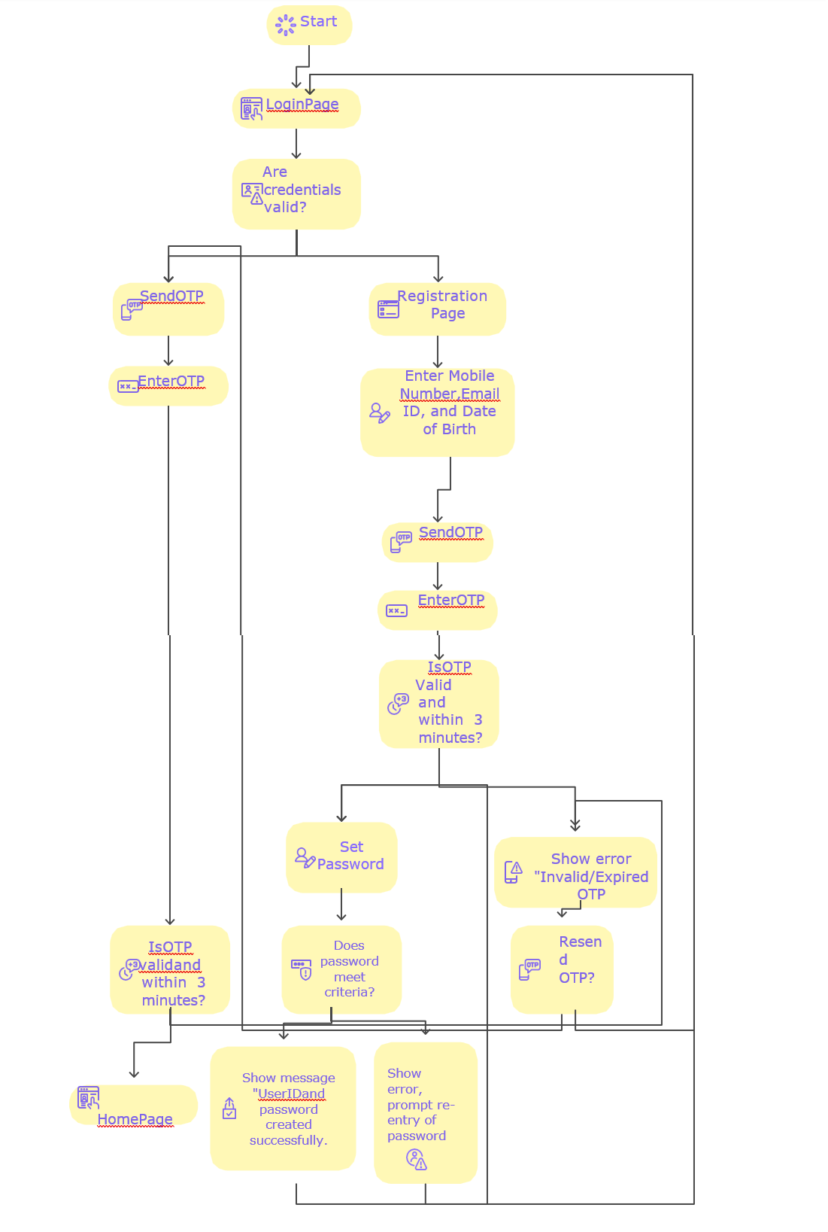

4.1.1 User Onboarding
- Purpose: Allow new and existing customers to register.
- Fields:
  - Policy Number: Customer’s existing policy number for validation.
  - Name: Full name as per policy records.
  - Date of Birth: For identity verification.
  - Mobile Number: Used for OTP verification.
  - Email ID: For communication and notifications.
  - Aadhaar / KYC Details: Government-approved identity verification.
- Details: Integration with KYC APIs for validation.

4.1.2 Login Authentication
- Purpose: Authenticate customers securely before accessing the portal.
- Fields:
  - Username / Policy Number: Unique identifier for the customer.
  - Password: Secret key for authentication.
  - OTP: One-time password for multi-factor authentication.
- Details: Includes “Forgot Password” and “Register” links.

4.2 Dashboard Page
- Purpose: This is the page that gets displayed to user after successful login.
- Fields:
  - My Policies (Document icon)
  - Payment (₹ icon)
  - Service Requests (Gear icon)
  - Notification & Support (Bell icon)
  - Service Requests Tracking (Checklist icon)
  - Policy Purchase (Document icon)
  - Tools & Utilities (Tools icon)
  - My Profile (User icon)

Wireframe for the Dashboard Page:
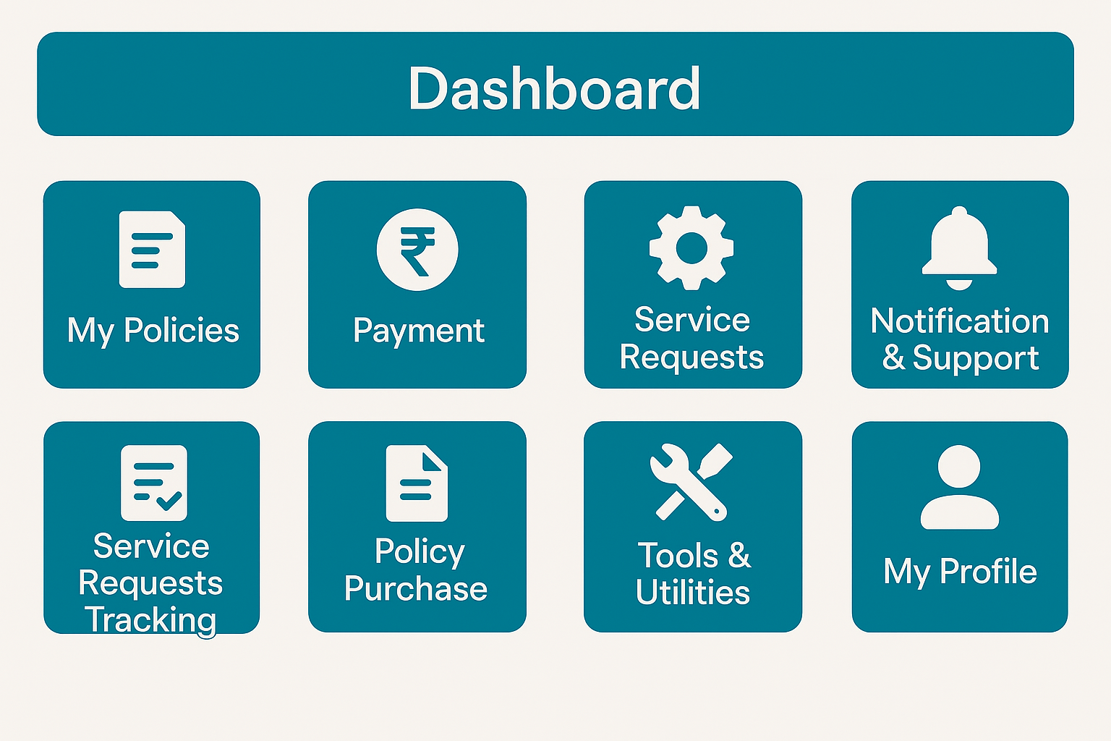

4.3 My Policies Page
- Purpose: Show details of all active policies.
- Fields:
- Policy Number: Unique identifier for each policy.
- Policy Type: Type of policy (PLI/RPLI).
- Sum Assured: Coverage amount.
- Premium Amount: Regular payment amount.
- Next Due Date: Upcoming premium payment date.
- Details: Option to download policy documents.

4.5 Payment Page
- Purpose: Enable premium and loan repayments.
- Fields:
  - Policy Number: Policy for which payment is being made.
  - Amount Due: Total payable amount.
  - Payment Mode: UPI, Net Banking, Credit/Debit Card.
- Details: Generates digital receipt and updates payment history.
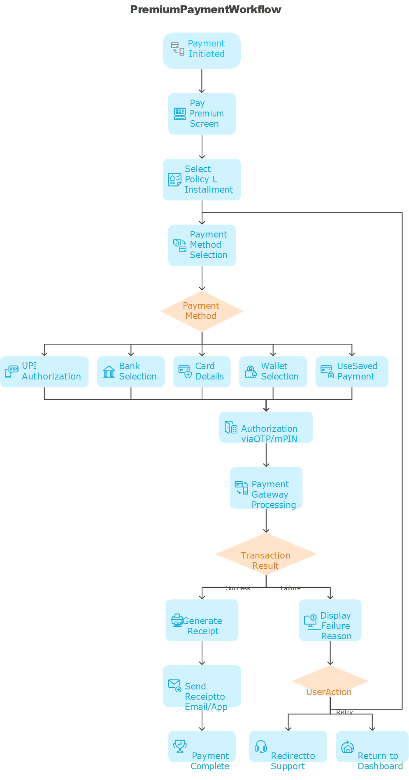

4.6 Service Request Page
- Purpose: Submit financial and non-financial requests.
- Fields:
  - Request Type: Claim, Policy Commutation, Conversion, etc.
  - Policy Number: Associated policy for the request.
  - Supporting Documents Upload: Required documents for processing.
- Details: OTP authentication for Type B requests.

4.7 Service Request Tracking Page
- Purpose: Track status of submitted requests.
- Fields:
  - Request ID: Unique identifier for each request.
  - Status: Pending, Approved, Rejected.
  - Last Updated Date: Timestamp of last update.
- Details: Real-time updates and SMS/email notifications.

4.8 Notification & Support Page
- Purpose: Provide alerts and customer assistance.
- Fields:
  - Notifications List: Premium due, claim updates, service status.
  - Chatbot / FAQ: Automated help and common queries.
  - Raise Ticket: Submit detailed query for resolution.
- Details: Includes escalation matrix and grievance redressal.

4.9 Policy Purchase Page
- Purpose: Explore and buy new policies.
- Fields:
  - Policy Type: Select PLI/RPLI product.
  - Age, Sum Assured, Term: Inputs for premium calculation.
  - Quote & Illustration: Generated based on inputs.
- Details: Upload documents, schedule medical tests, track proposal.

4.10 Tools & Utilities Page
- Purpose: Provide additional resources.
- Fields:
  - Request Agent: Submit request for agent assistance.
  - Locate Agent: Find nearest agent by PIN code.
  - Download Forms: Access policy-related forms.
  - Submit Query: Raise general queries.
- Details: Includes Privacy Policy and Customer Guidelines.

4.11 My Profile Page
- Purpose: Manage personal details.
- Fields:
  - Name: Editable if allowed.
  - Mobile Number: Update with OTP verification.
  - Email: Update for communication.
  - Change Password: Secure password update.
- Details: All changes logged for audit.

Part 1: New PLI Policy Purchase Flow - Application & Eligibility
NEW PLI POLICY PURCHASE FLOW - PART 1/2: APPLICATION & ELIGIBILITY
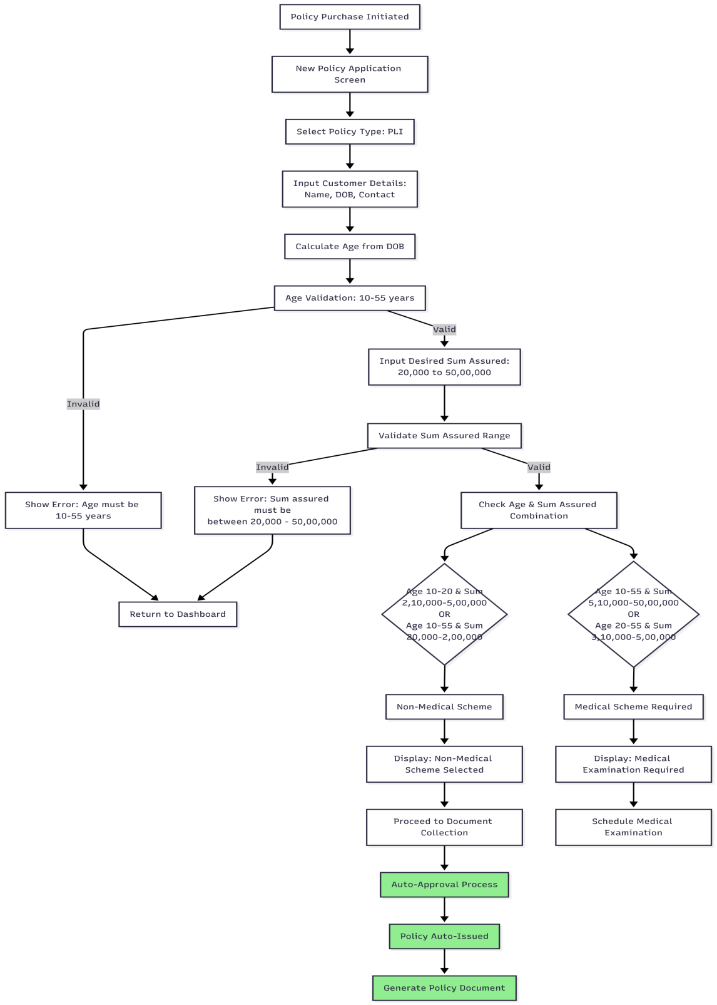
Part 2: New PLI Policy Purchase Flow - Medical & Finalization
NEW PLI POLICY PURCHASE FLOW - PART 2/2: MEDICAL & FINALIZATION
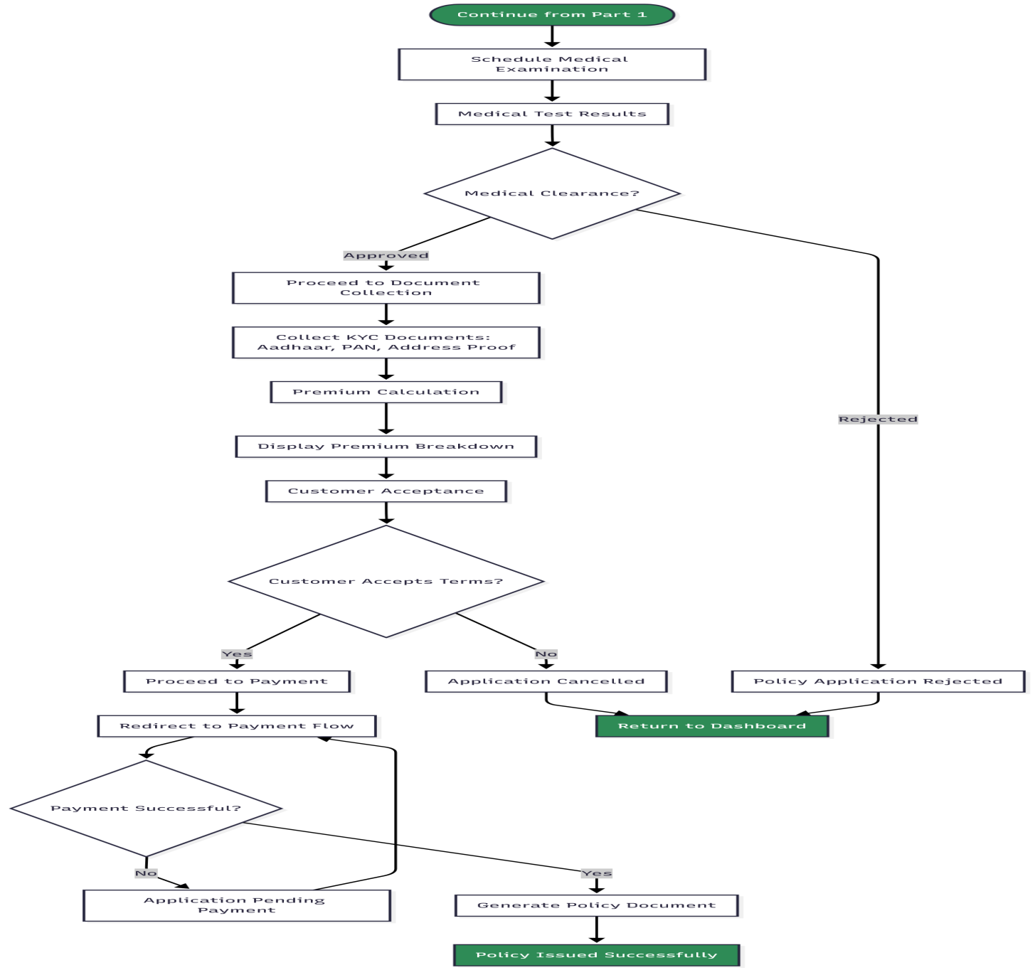

Medical Requirement Decision Matrix (For Reference)
PLI MEDICAL REQUIREMENT MATRIX
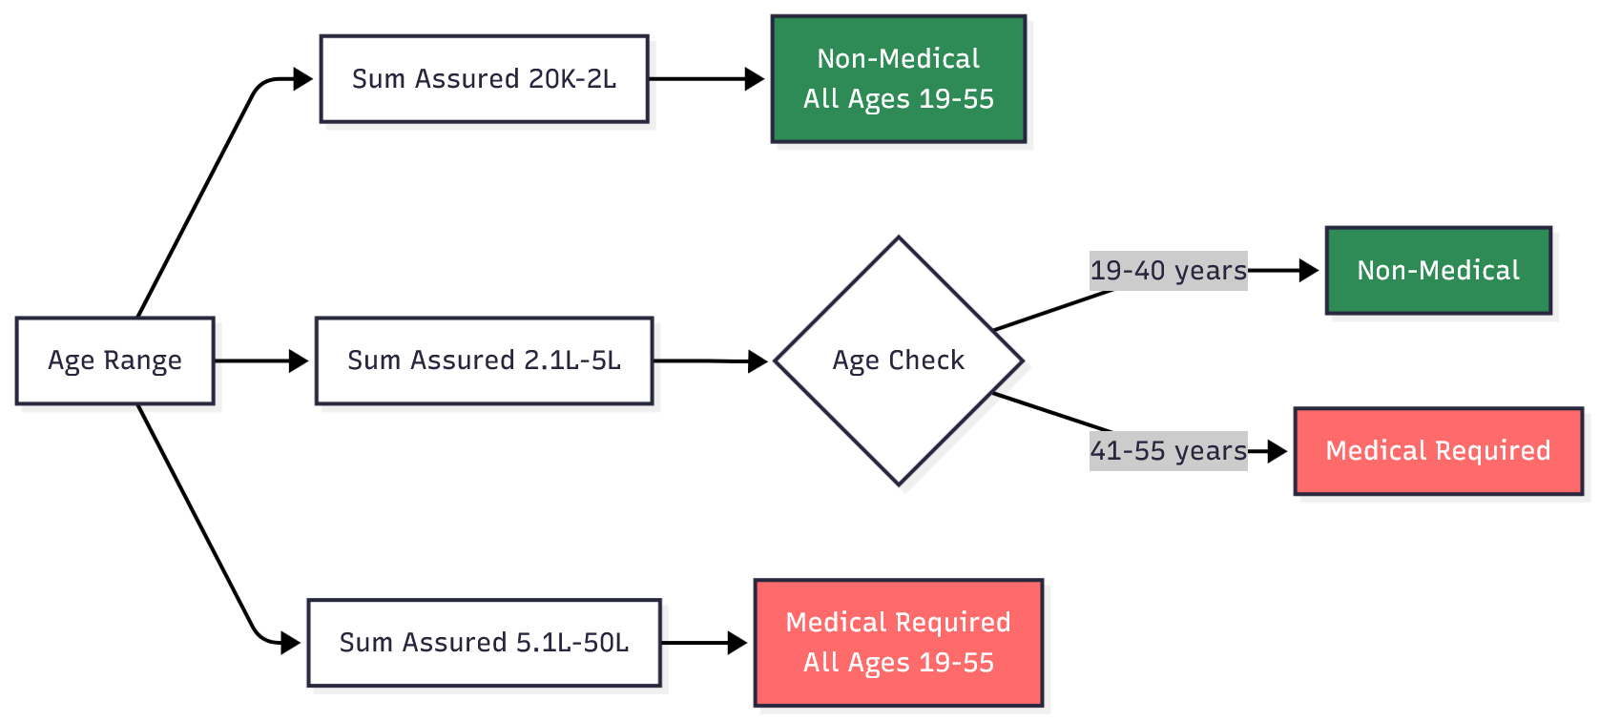

Part 1: New RPLI Policy Purchase Flow - Application & Rural Validation
NEW RPLI POLICY PURCHASE FLOW - PART 1/2: APPLICATION & RURAL VALIDATION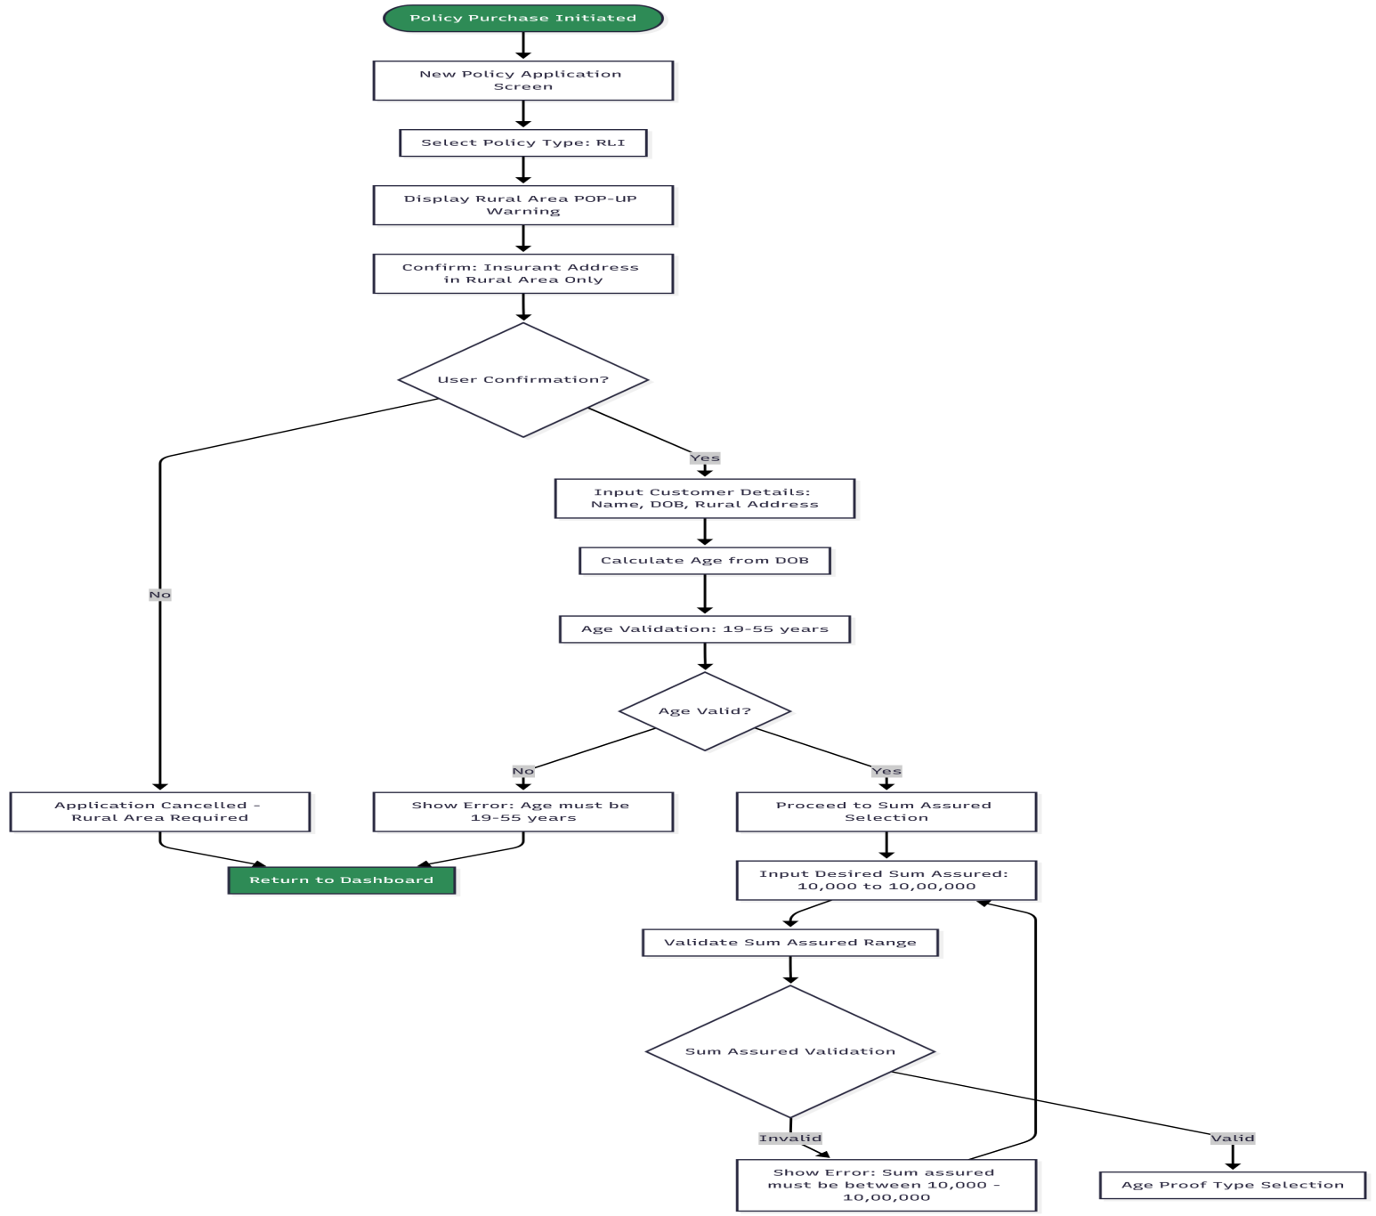

Part 2: New RPLI Policy Purchase Flow - Age Proof & Medical Requirements
NEW RPLI POLICY PURCHASE FLOW - PART 2/2: AGE PROOF & MEDICAL REQUIREMENTS
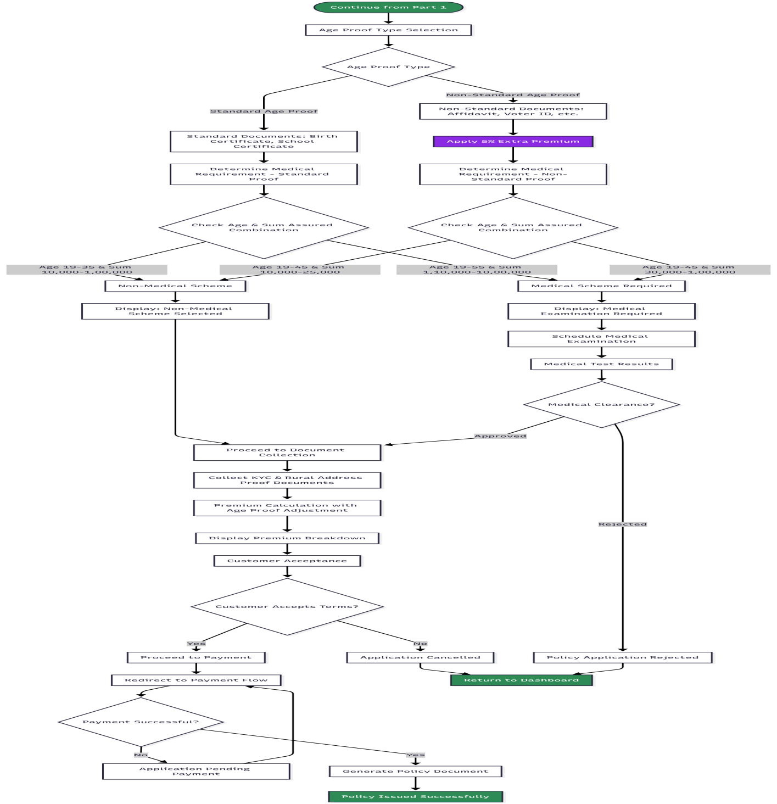

PLI Medical Requirement Decision Matrix (For Reference)
RPLI MEDICAL REQUIREMENT MATRIX
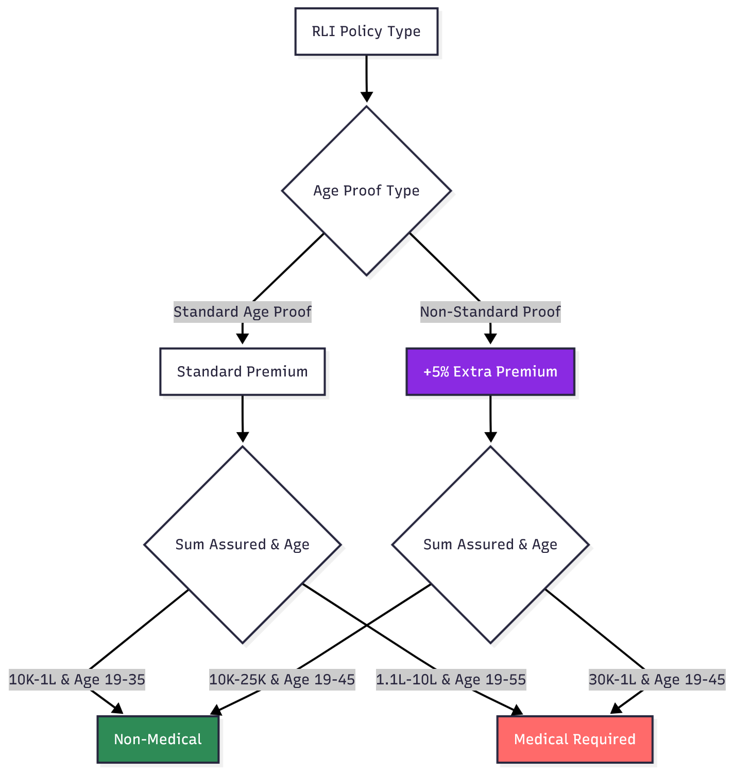

1. Non-Financial Service Requests - Type A (Post Office Verification Required)

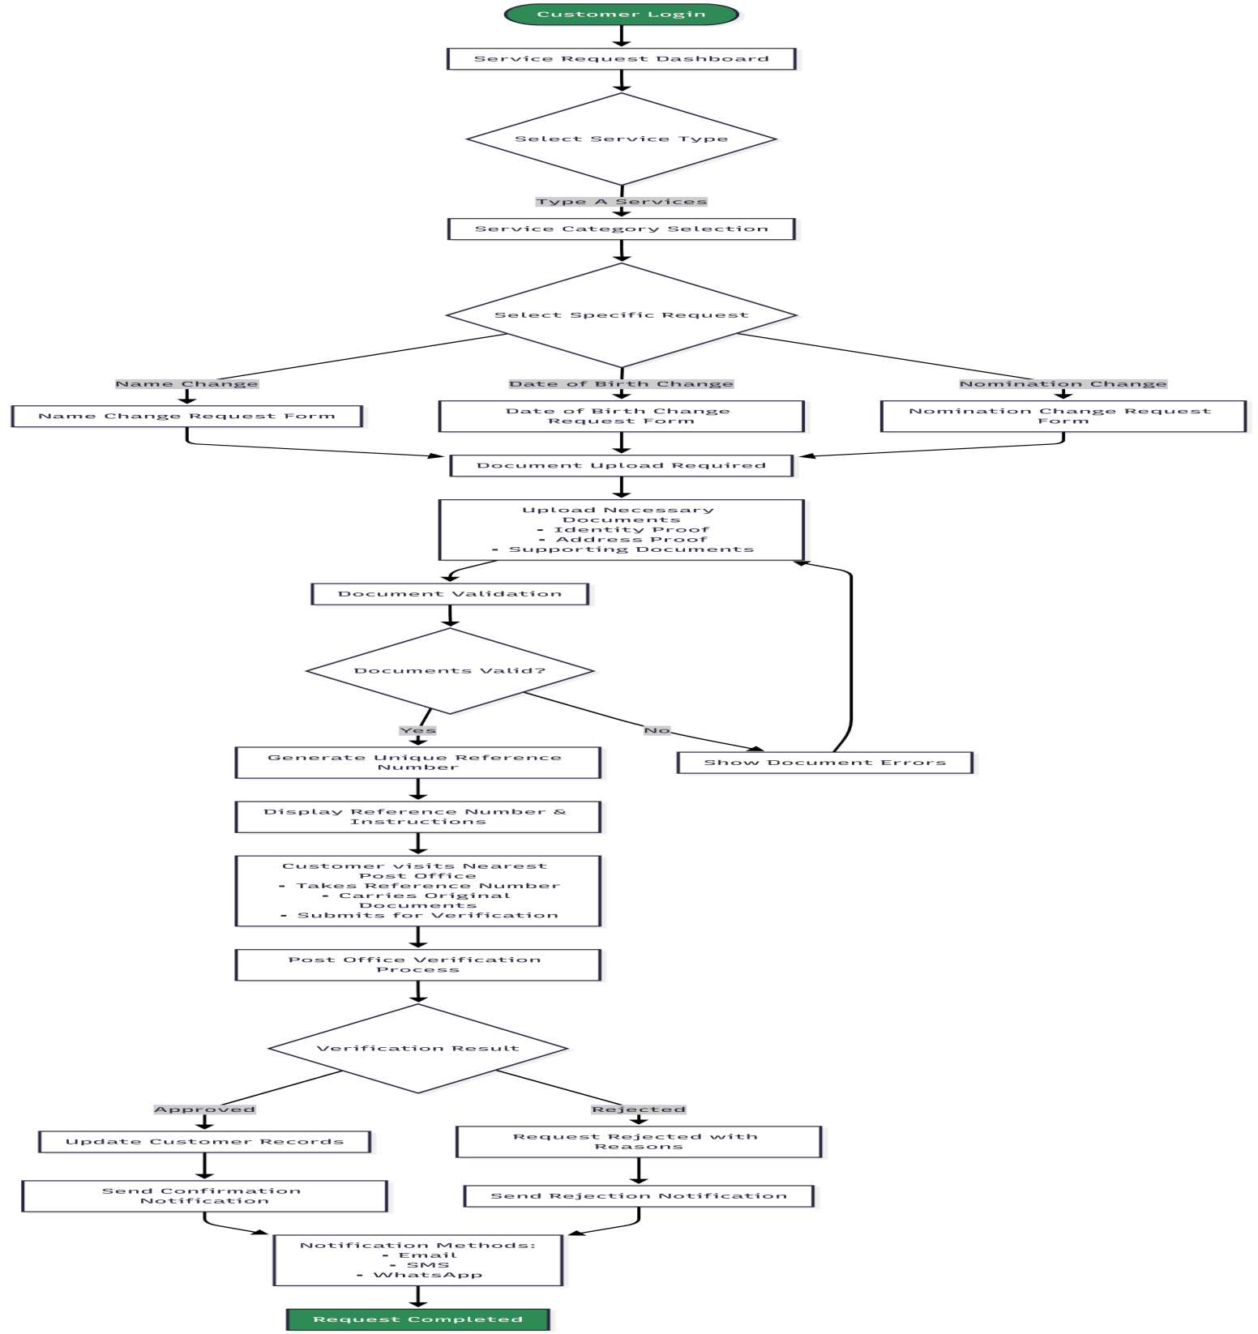

2. Non-Financial Service Requests - Type B (OTP Authentication Only)

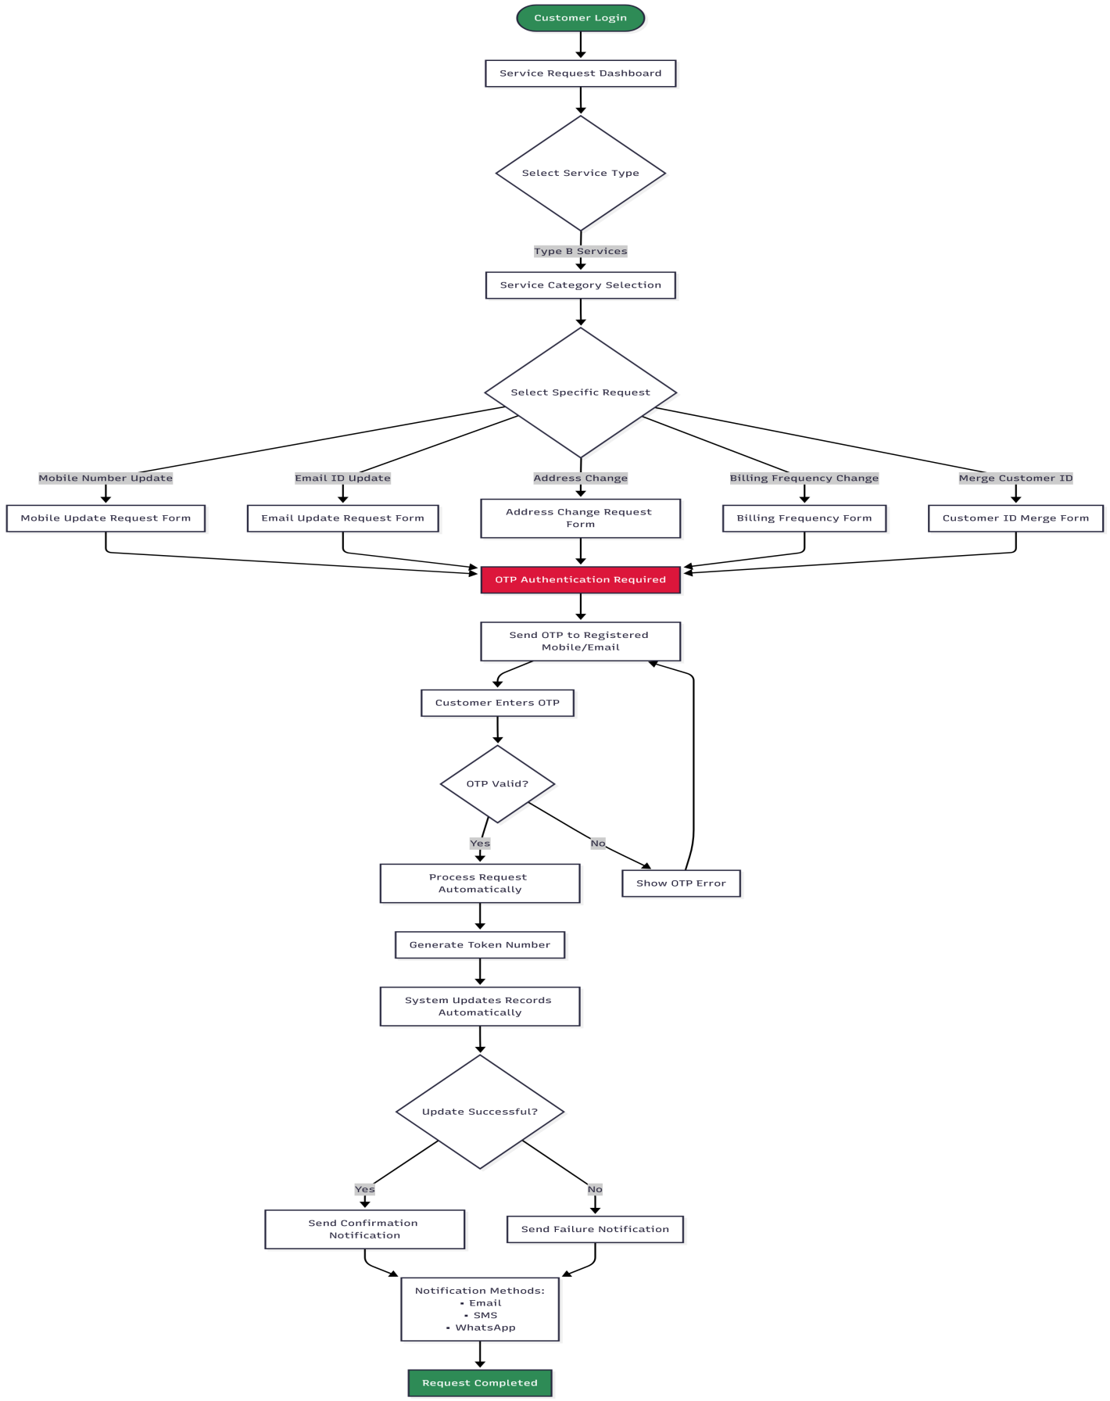
Part 1: Claims Initiation & Eligibility Check
CLAIMS FLOW - PART 1: INITIATION & ELIGIBILITY
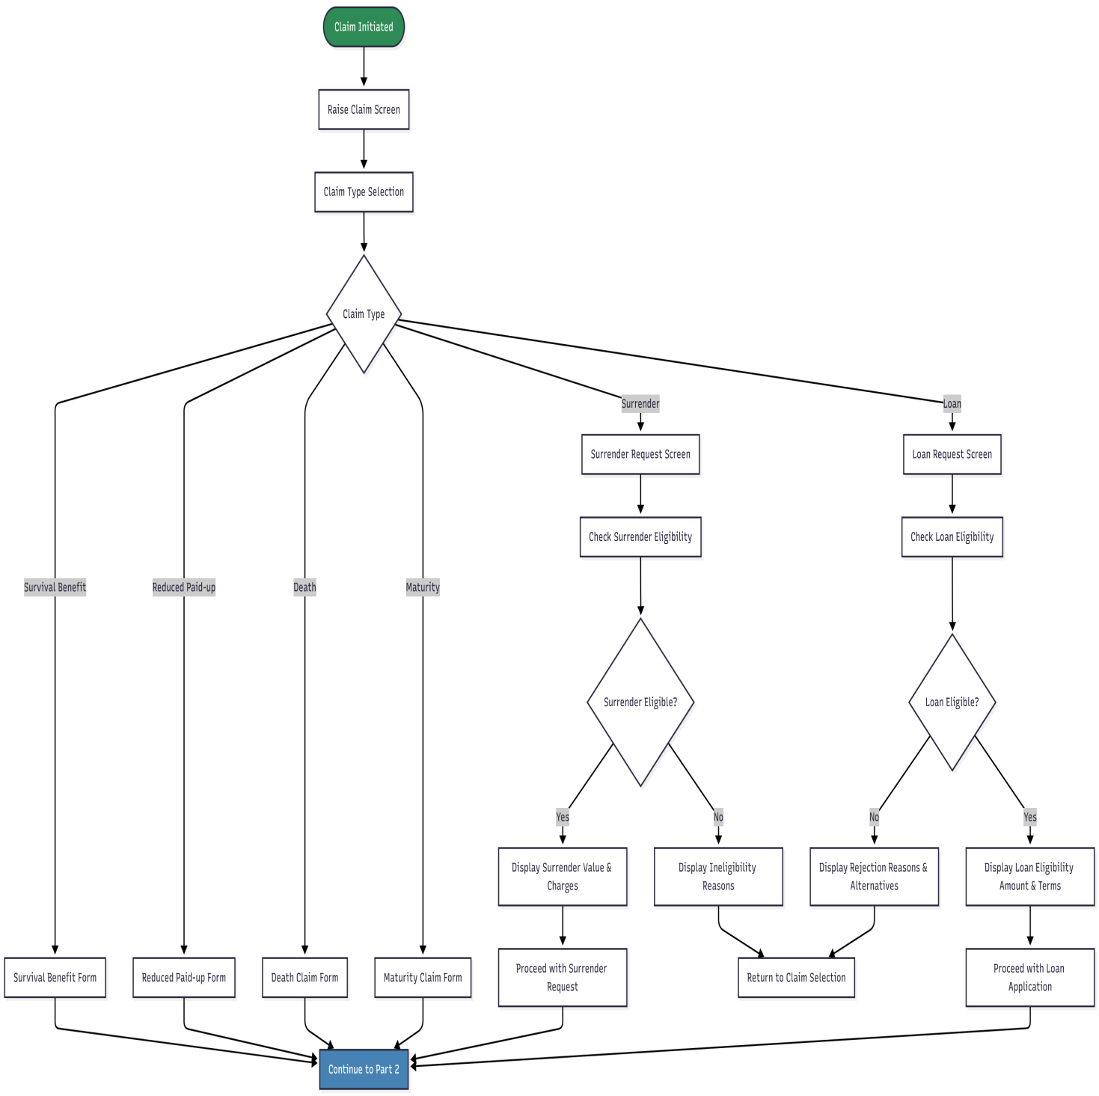

Part 2: Bank Details Verification & Document Upload
CLAIMS FLOW - PART 2: BANK VERIFICATION & DOCUMENTS
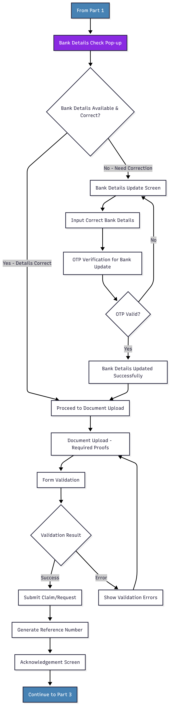

Part 3: Notifications & Tracking
CLAIMS FLOW - PART 3: NOTIFICATIONS & TRACKING
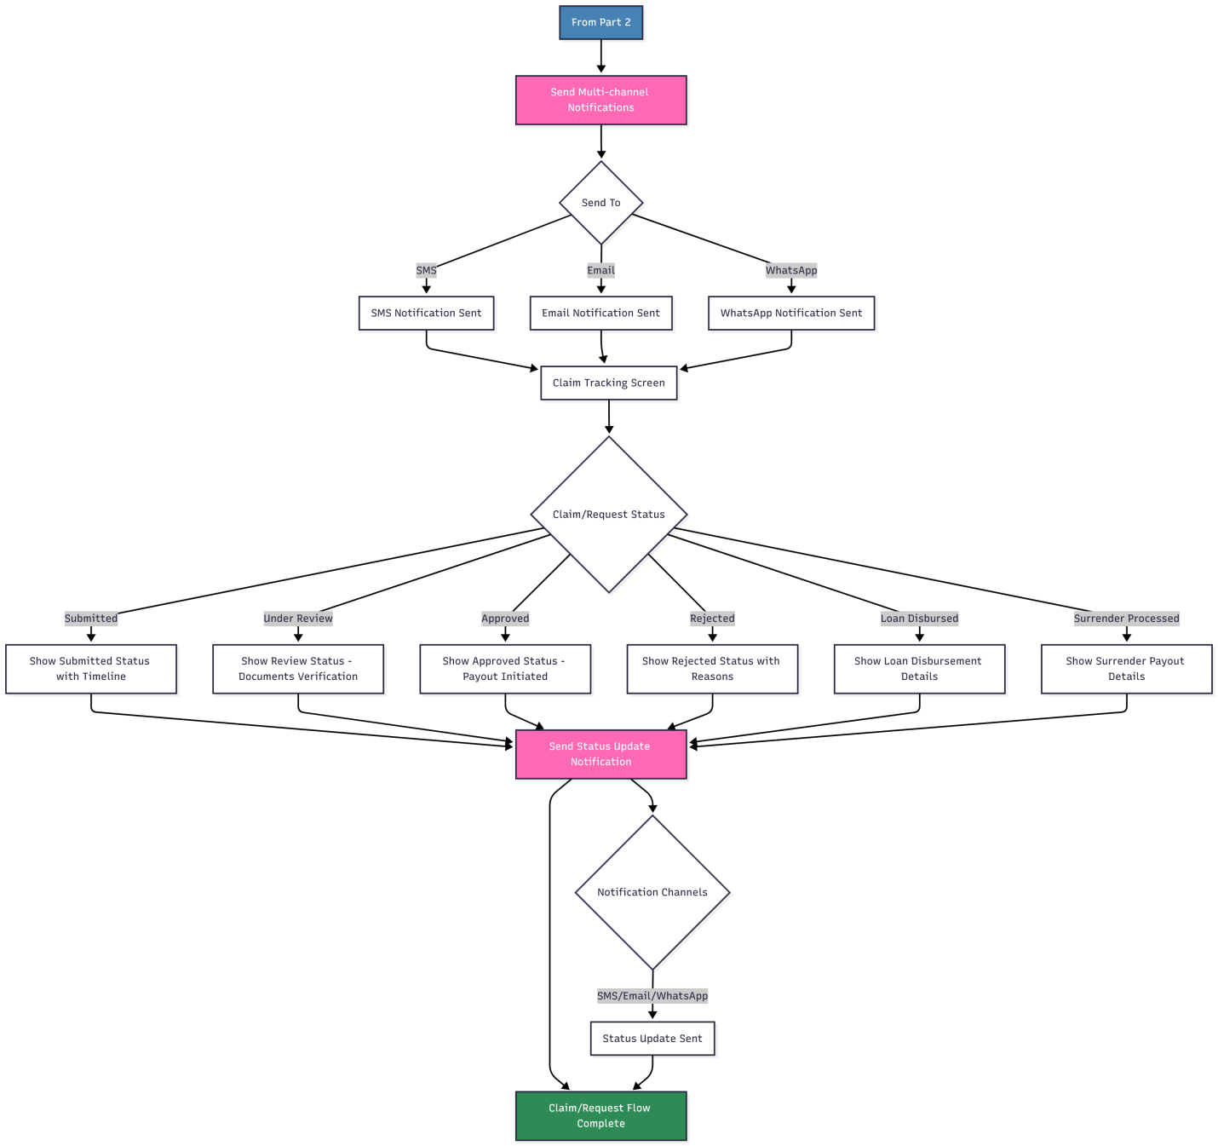

Part 1: PLI Policy Commutation - Contract Alteration Eligibility
PLI POLICY COMMUTATION FLOW - PART 1/4: CONTRACT ALTERATION ELIGIBILITY
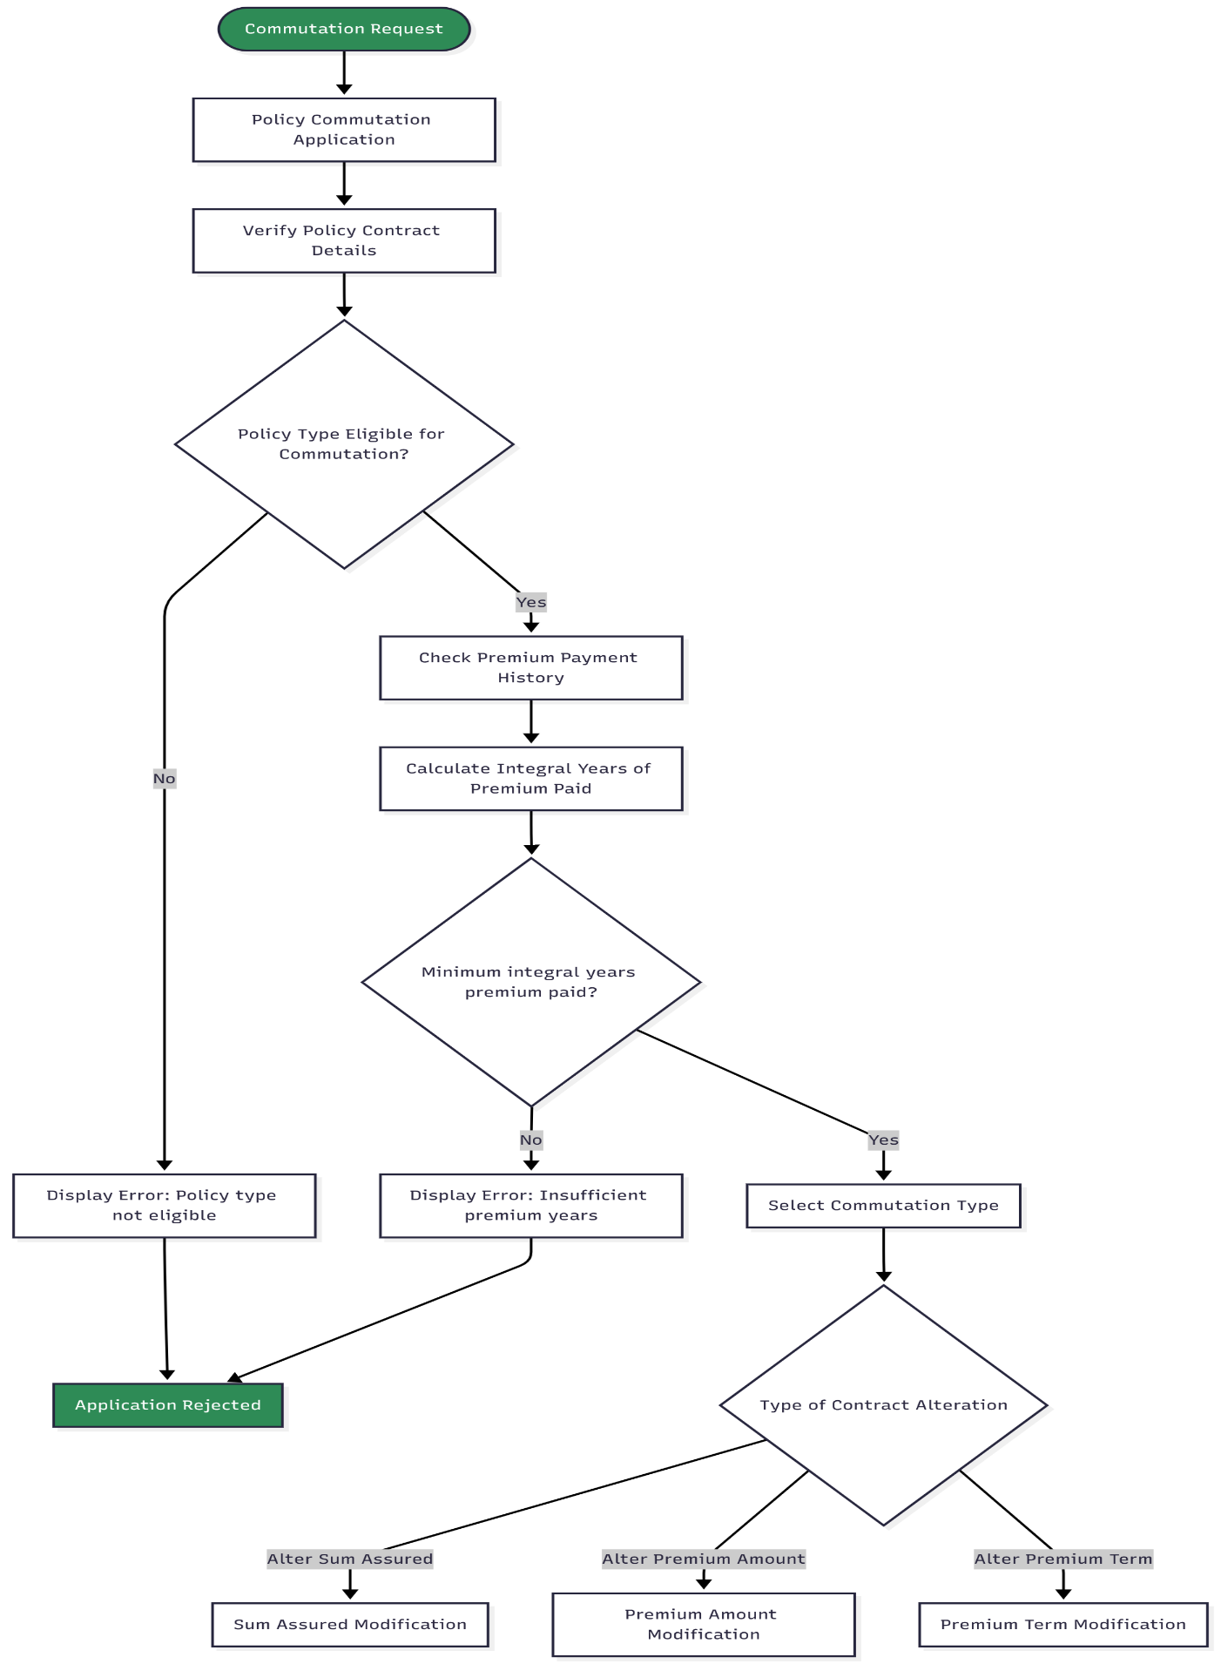
Part 2: PLI Policy Commutation - Alteration Type Processing
PLI POLICY COMMUTATION FLOW - PART 2/4: ALTERATION TYPE PROCESSING
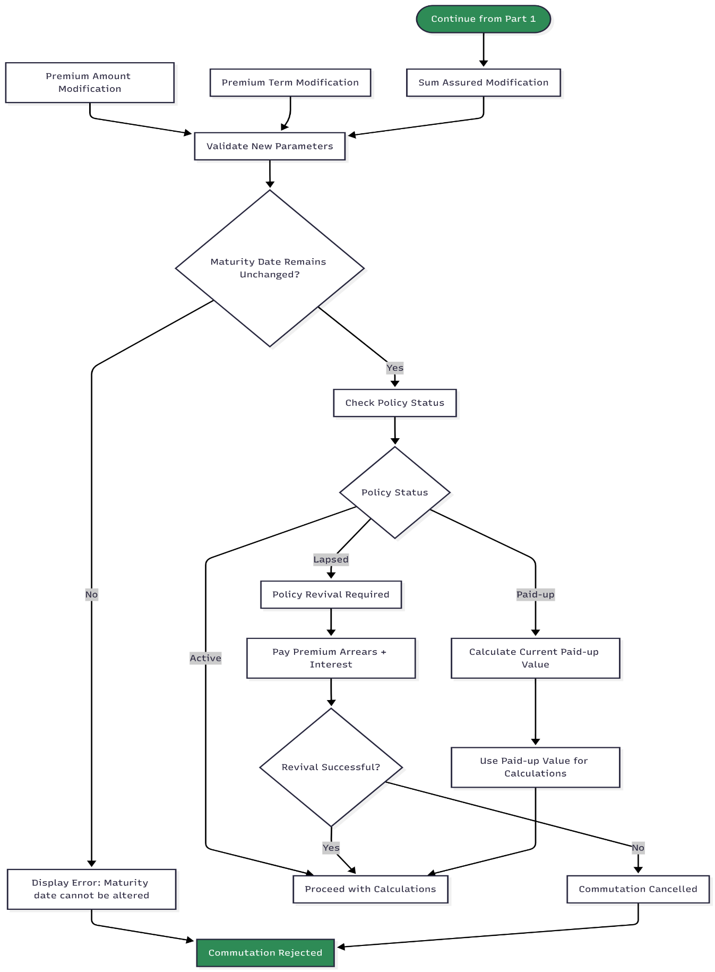
Part 3: PLI Policy Commutation - Financial Calculations & Validation
PLI POLICY COMMUTATION FLOW - PART 3/4: FINANCIAL CALCULATIONS
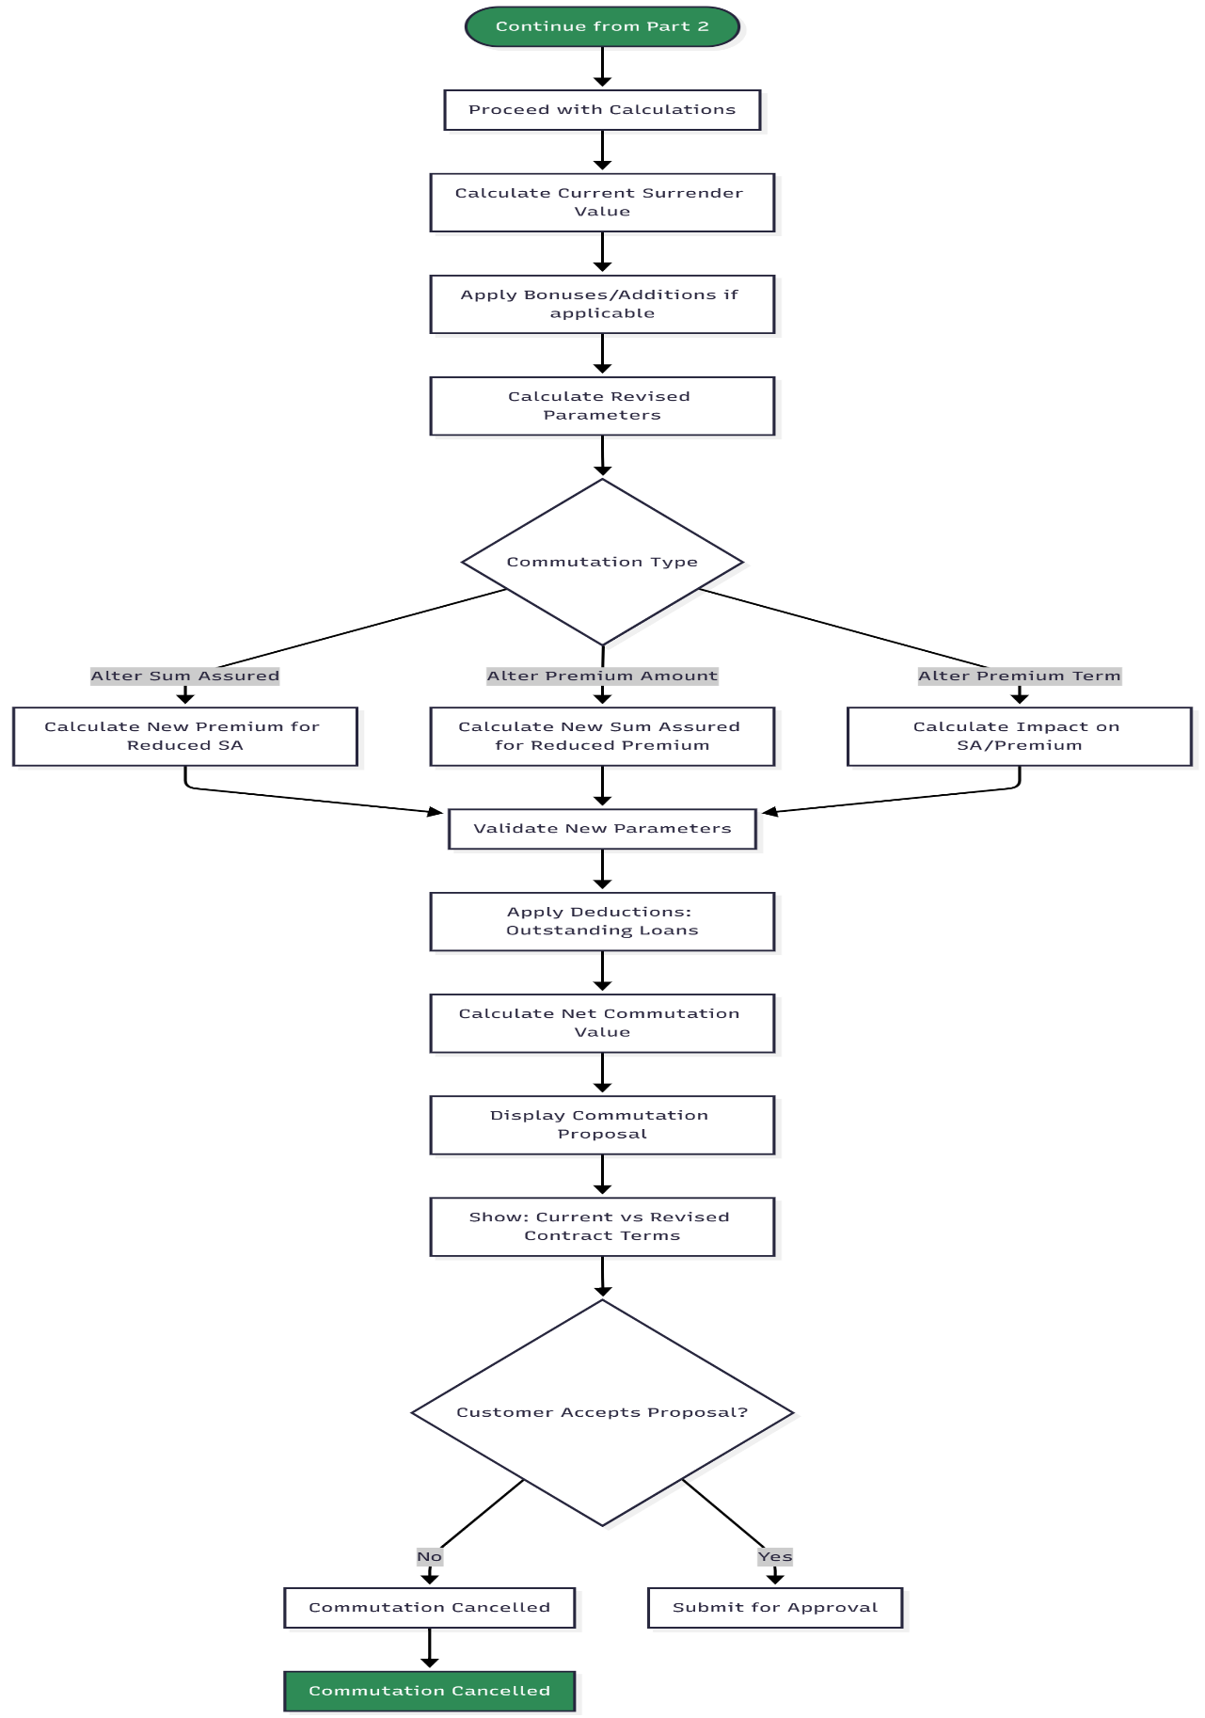
Part 4: PLI Policy Commutation - Approval & Contract Update
PLI POLICY COMMUTATION FLOW - PART 4/4: APPROVAL & UPDATES
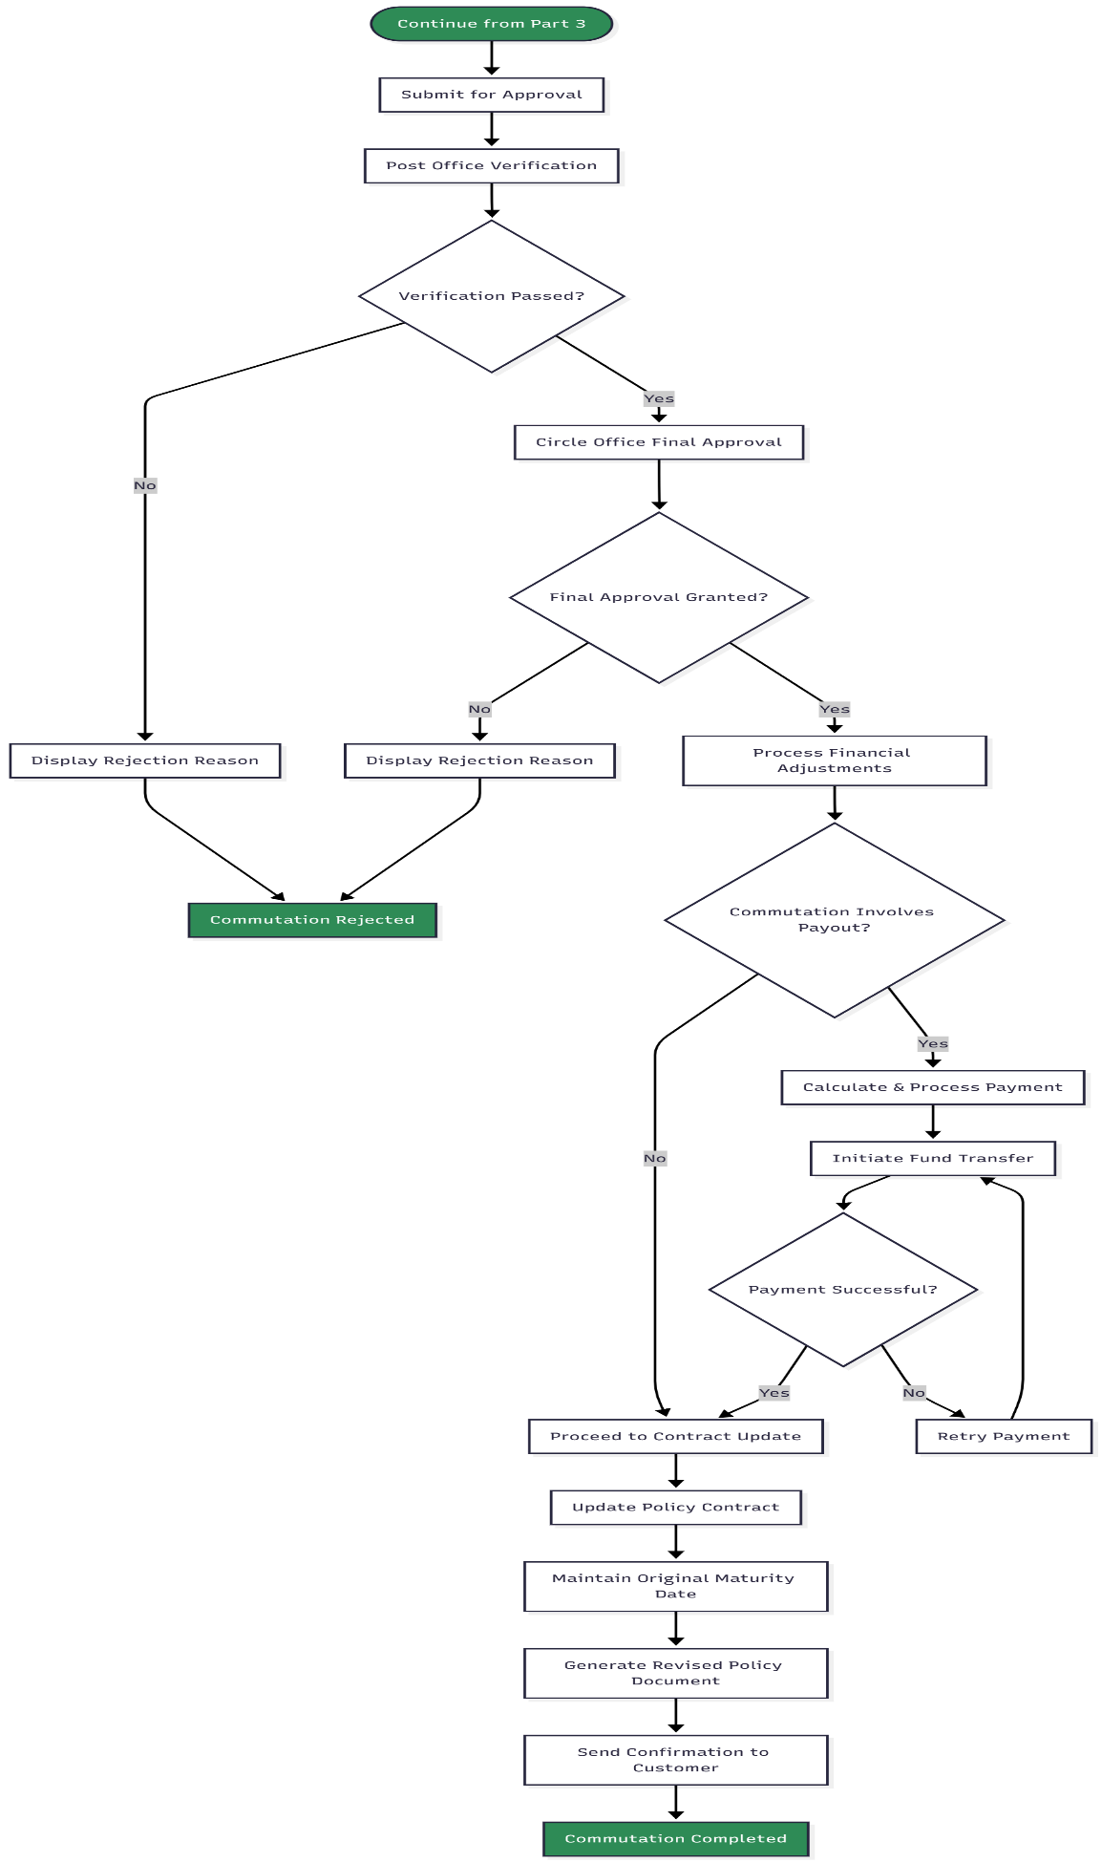
PLI Commutation Rules Summary (For Reference)
COMMUTATION TYPES MATRIX
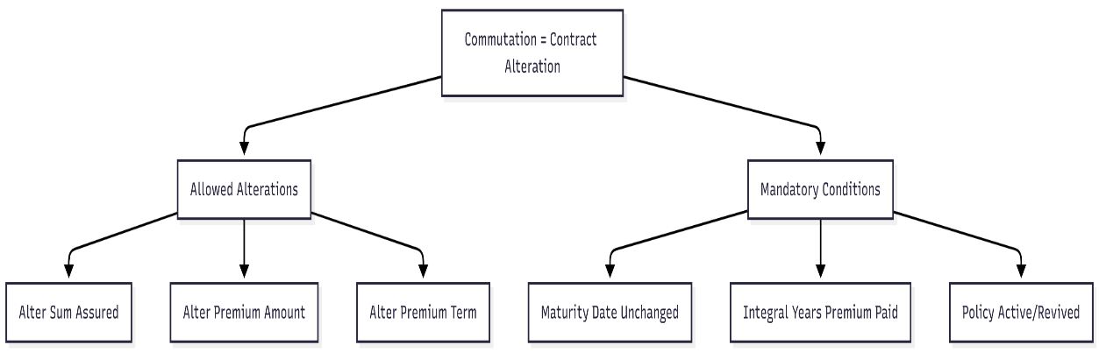

Part 1: PLI Policy Conversion - Eligibility & Type Selection
PLI POLICY CONVERSION FLOW - PART 1/4: ELIGIBILITY & TYPE SELECTION
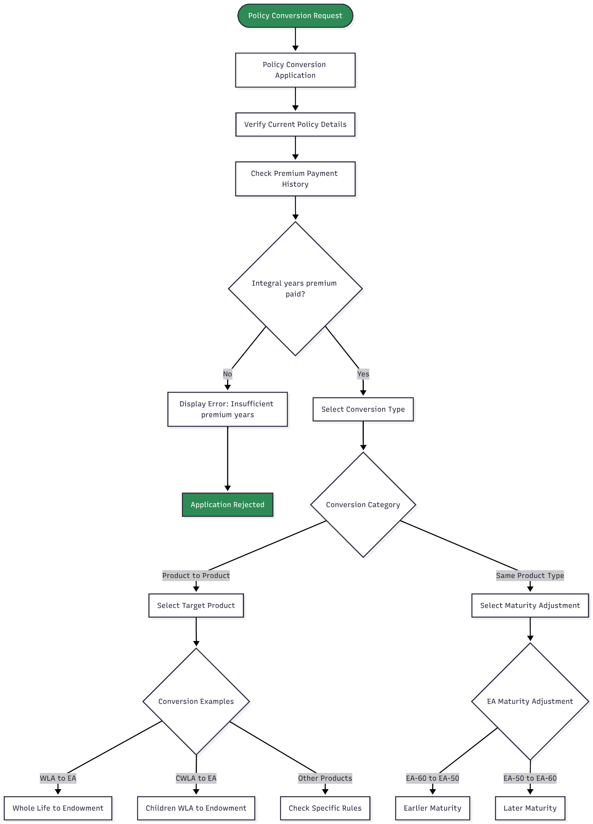
Part 2: PLI Policy Conversion - Maturity Date & Medical Check
PLI POLICY CONVERSION FLOW - PART 2/4: MATURITY & MEDICAL REQUIREMENTS
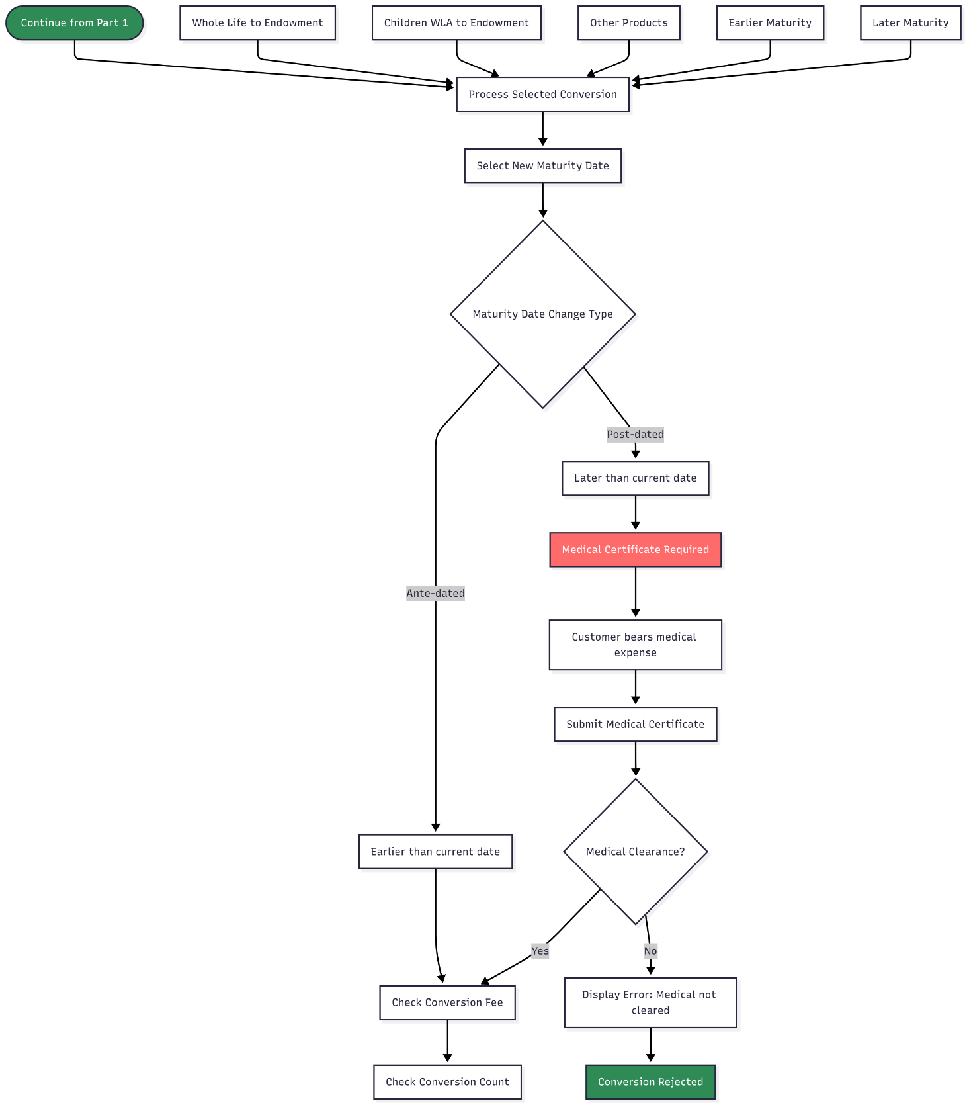

Part 3: PLI Policy Conversion - Fee Calculation & Bonus Treatment
PLI POLICY CONVERSION FLOW - PART 3/4: FEE & BONUS CALCULATIONS
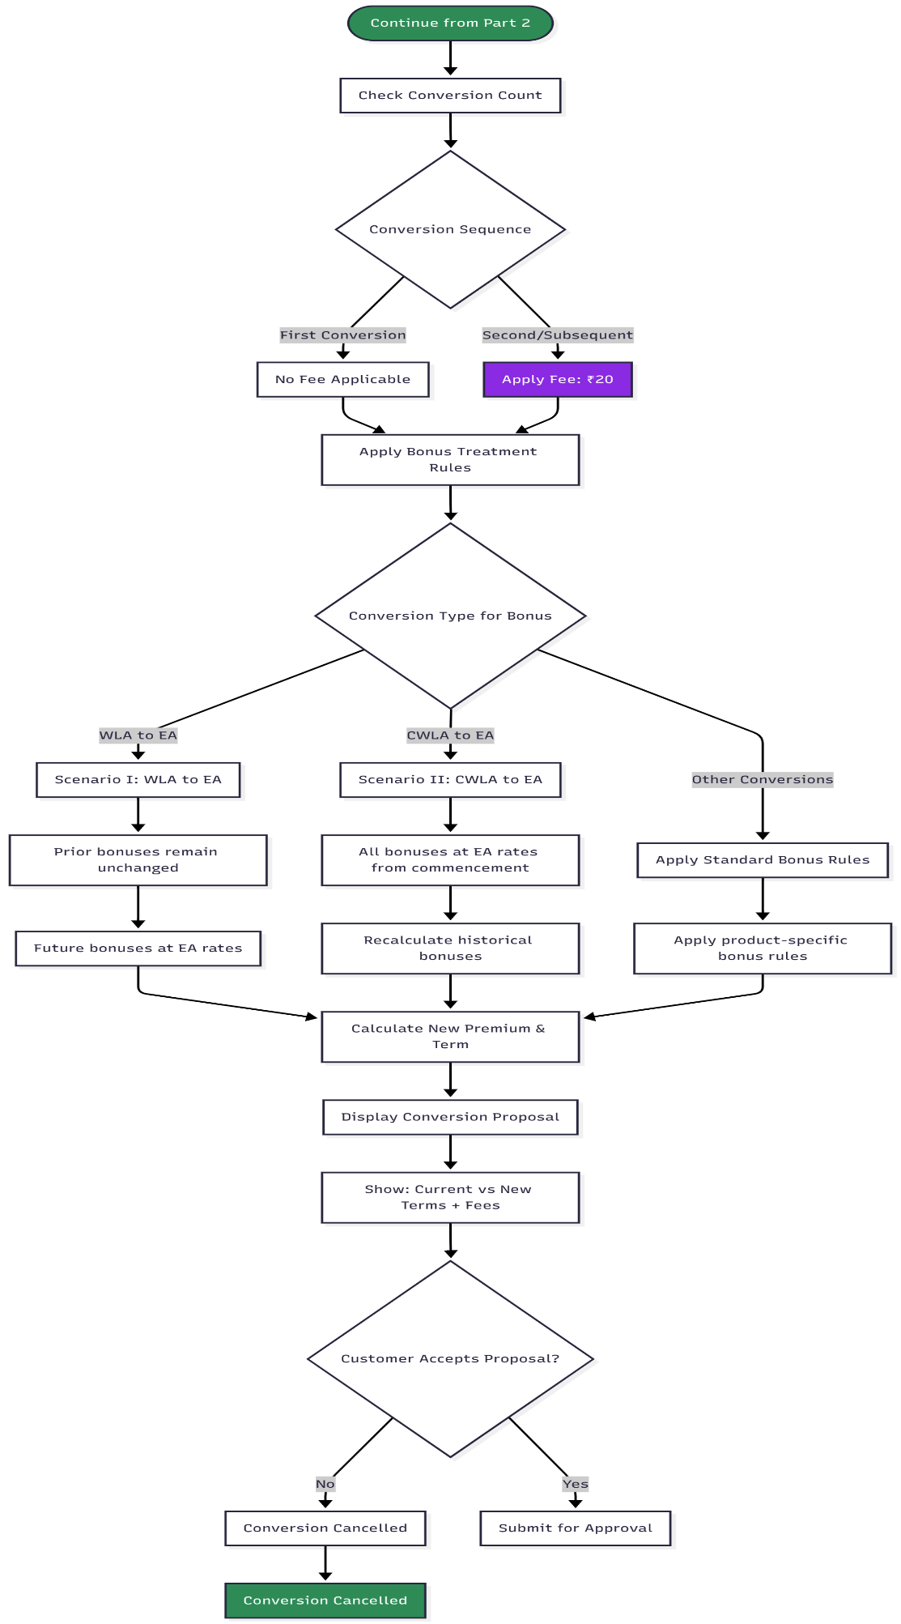
Part 4: PLI Policy Conversion - Approval & Policy Update
PLI POLICY CONVERSION FLOW - PART 4/4: APPROVAL & IMPLEMENTATION
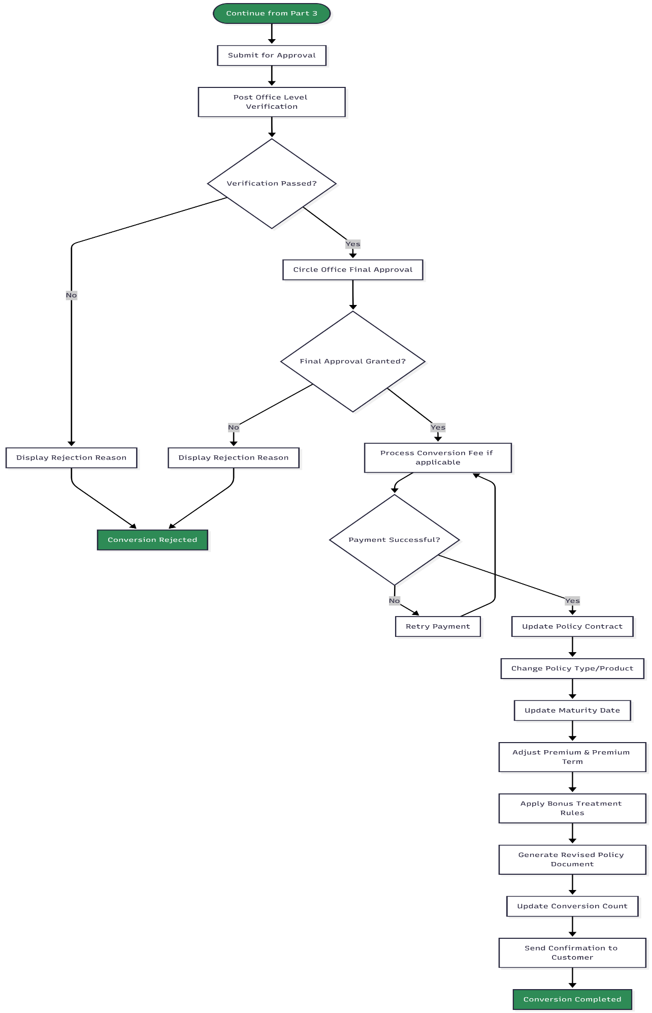
PLI Conversion Rules Summary (For Reference)
CONVERSION TYPES MATRIX
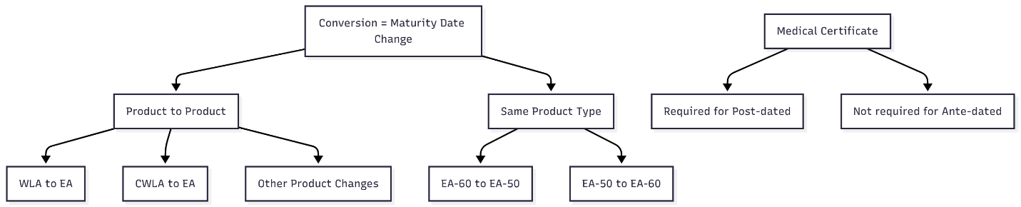

Security & Session Management Flow chart:
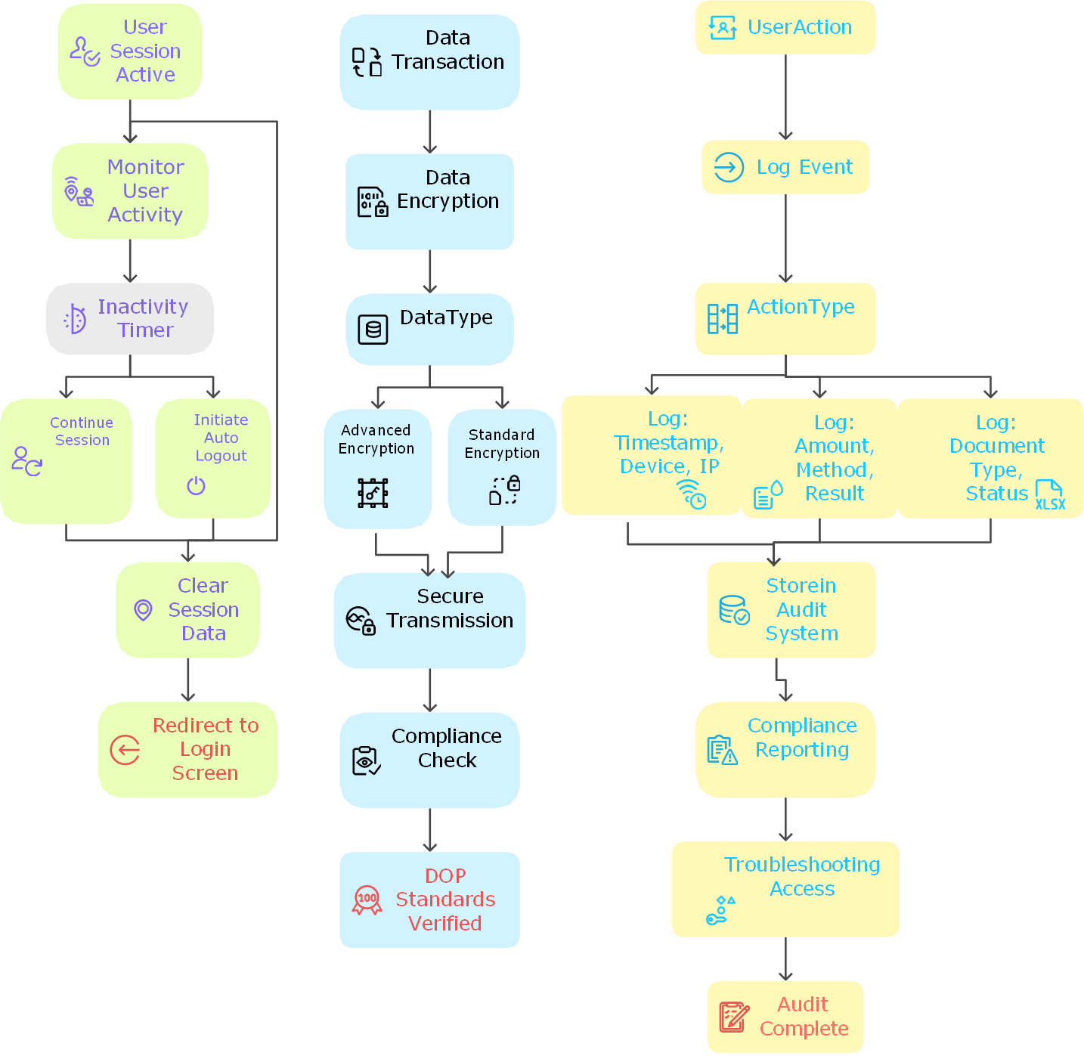

5. Appendices
The Following Documents attached below can be used.

